WCS BUILD AND DEPLOYMENT

DEPLOYMENT IN HIGHER ENVIRONMENT (EX: HOTFIX, UAT2 and PROD)

- Go to Utilities-Set Build Number-build with parameters
- Give the corresponding package to deploy(ex: wcs_b_r59206_20May2016_RAMS5.0_58)
- Then click on build.

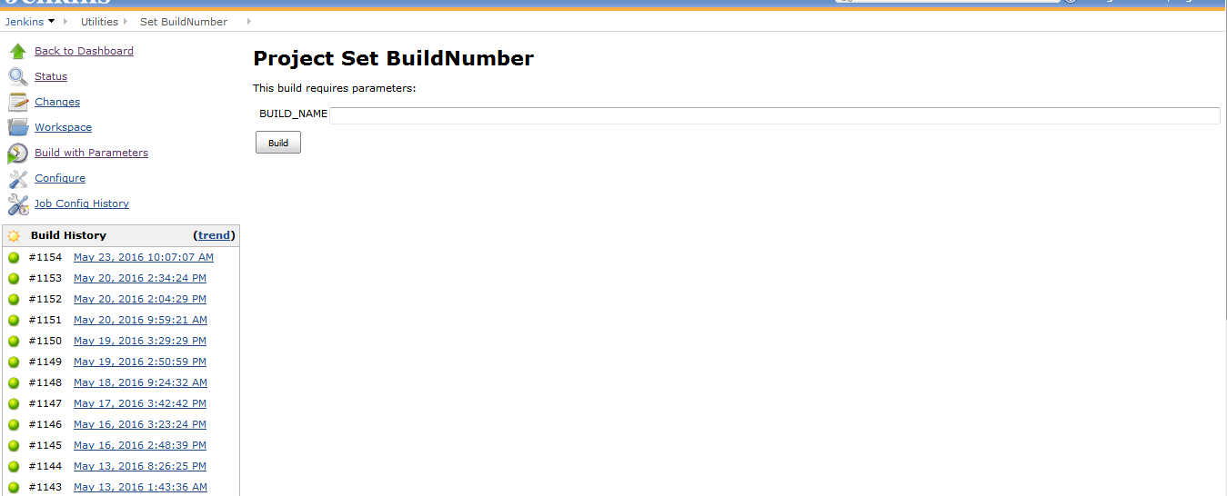

d. Then do below 3 steps jobs to complete full deployment which are:

- Deploy HOTFIX-LIVE code deployment to DMGR).
- HOTFIX-LIVE Node Sync and custom ear deployments
- Deploy HOTFIX-LIVE Static assets ,solr and DLP files

Here step 2 & 3 need to be executed in parallel.

4. Go to Hotfix live jobs-Project HOTFIX LIVE - Code deployment to DMGR

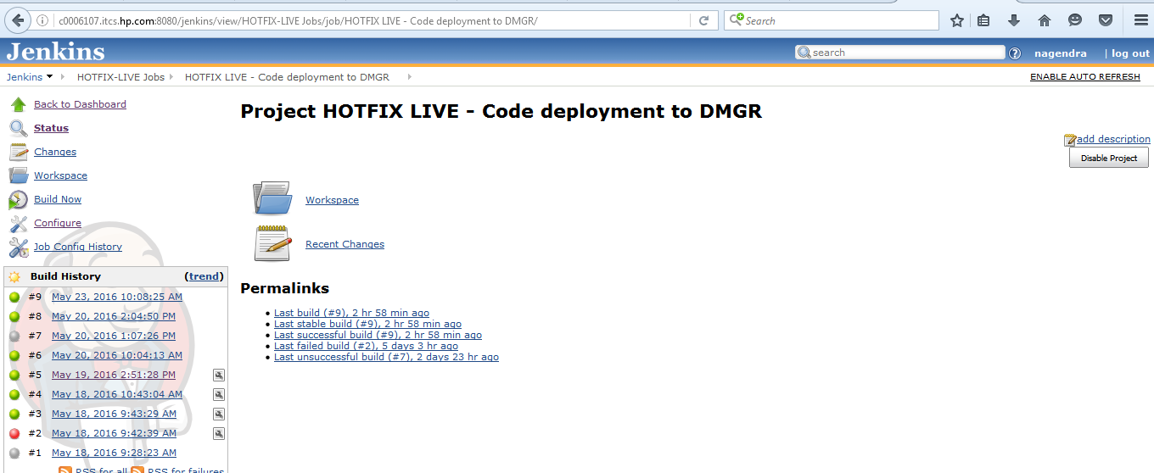

5. Then click on “Build Now”.

6. Then go to Hotfix-live jobs-Project HOTFIX-LIVE - Node Sync and EAR deploy

7. Then click on “Build Now”.

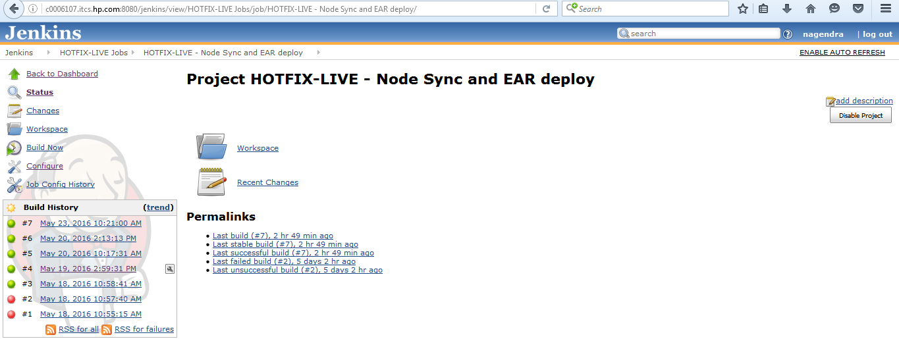

7.Then go to Hotfix-live jobs- Project HOTFIX-LIVE - Static assests ,solr and DLP files.

8. Then click on “Build Now”.

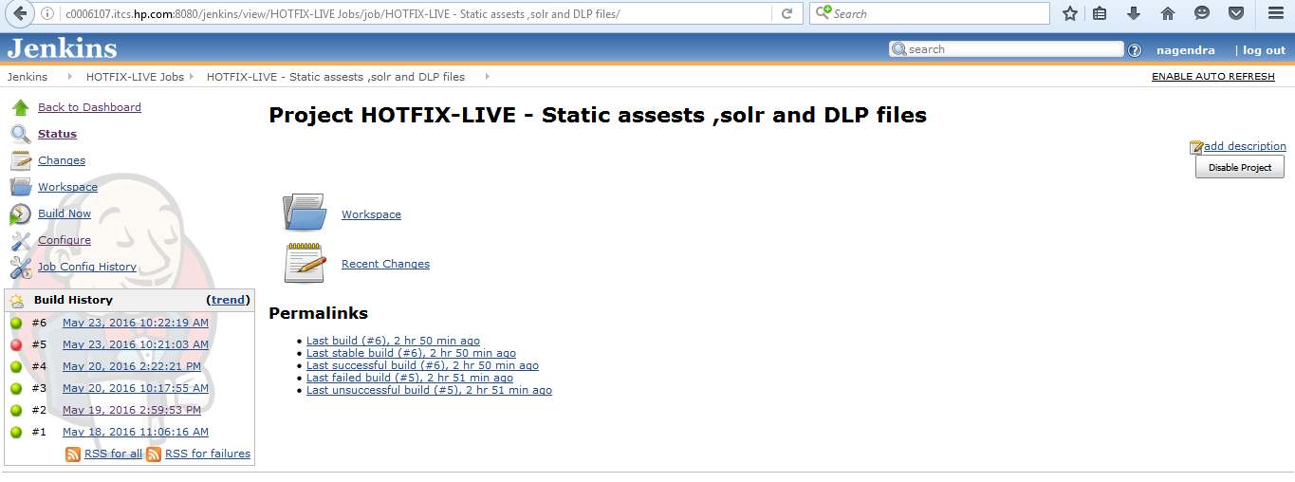

OMS BUILD AND DEPLOYMENT

Take the revision number from the build no provided in release notes OMS_b_r59143_24May2016_AMS5.0_HOTFIX_6 (ex: r59143)

- Go to JenkinsBuild Jobs-Build to Hotfix Live
- Give the Revision number (ex: r59143) and select “trunk” as ETR type and “LABEL” as OMS_t type and click build.

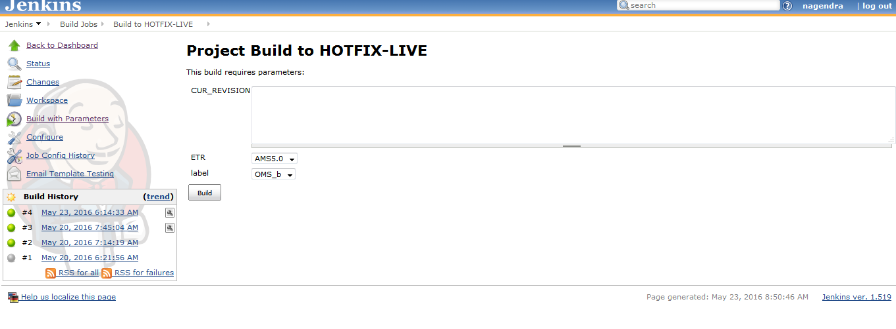
- Then take the build package name from the build logs (ex: OMS_t_r59143_23May2016_AMS5.0_HOTFIX_6)
- Go to Deploy jobs-set build numberbuild with parameters
- Give the above taken build package and click build.

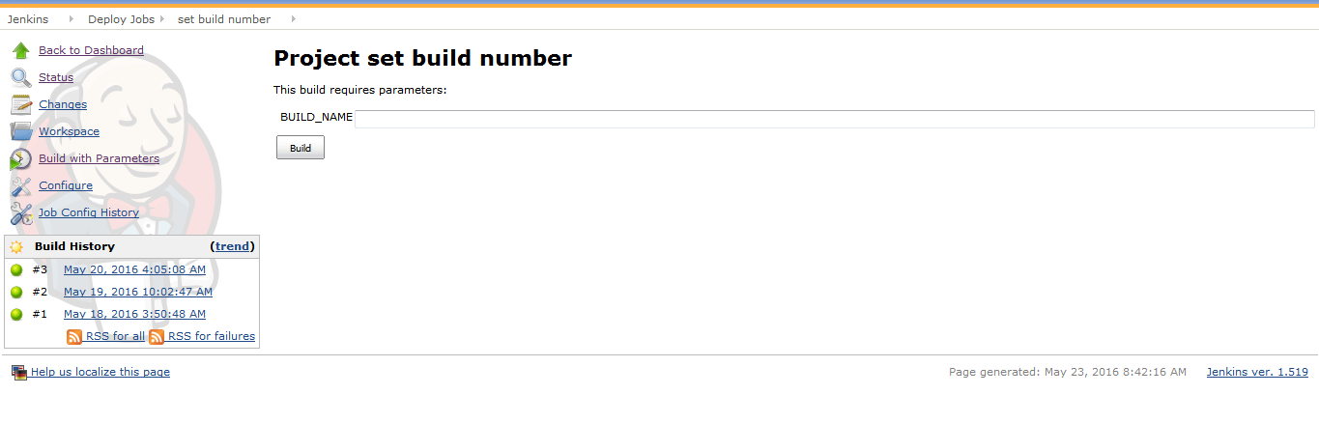

- Then go to Deploy Jobs-Deploy Hotfix liveBuild now

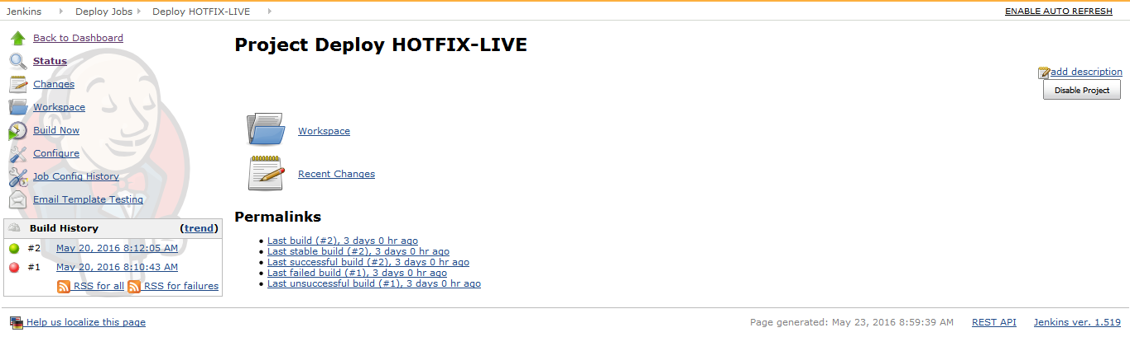

SEARCH BUILD AND DEPLOYMENT
Follow the same steps for the search as WCS , here only difference is we have 2 steps in Search.

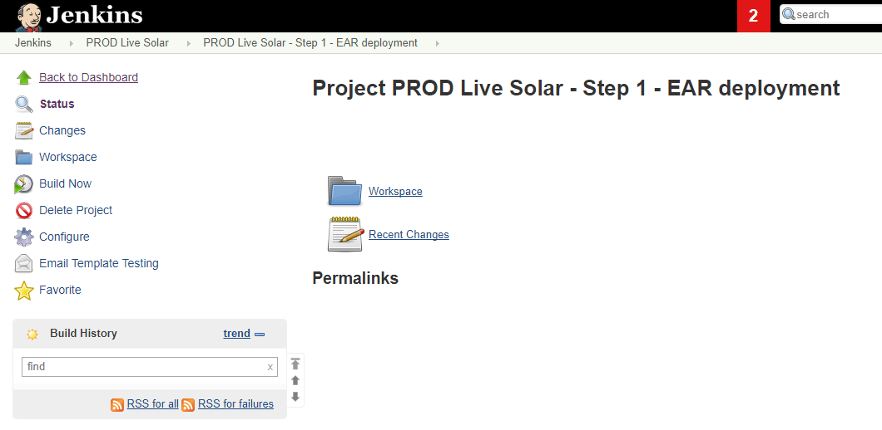
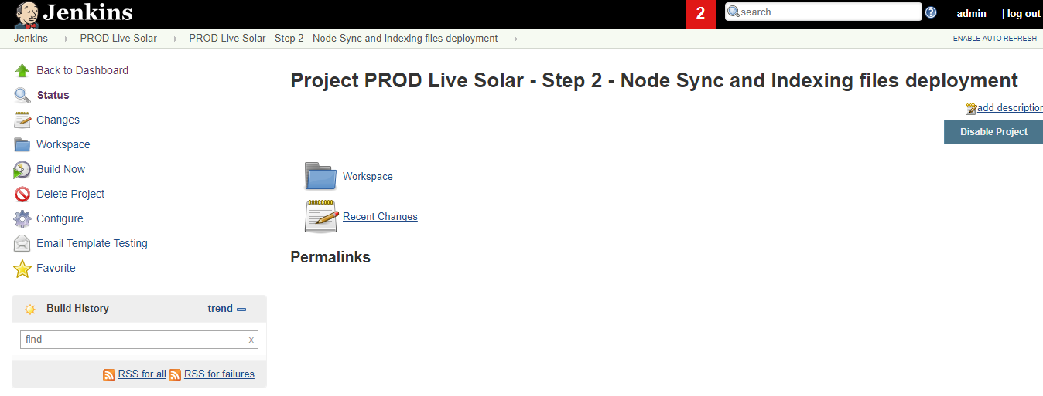

CTO:
CONFIGURATOR BUILD AND DEPLOYMENT (for Both Stage and Live):
This need to be done in Putty box:

1. Open CTO Build box - c9t27233.itcs.hpicorp.net
2. cd /opt/apps/IBM/scripts/
3. Run the following commands
ll
vi init_Configurator.sh
4. For Ex: The Given CTO Build is Configurator_t_r46066_02Feb2015_code3.0
Change svn branch= code3.0 and svn_tag= Configurator_t_r46066_02Feb2015_code3.0 in inti.sh and save.
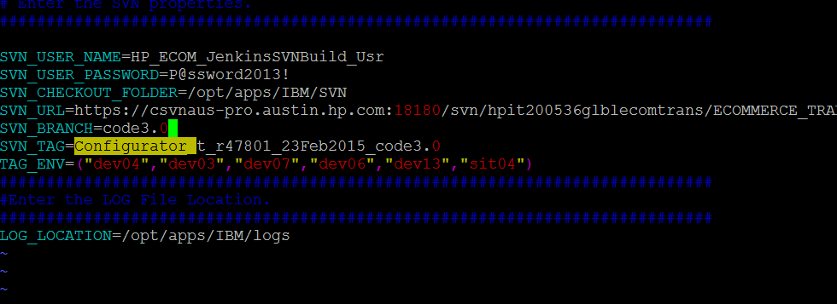
Run the below Scripts (if there is no static content move – check with Leads)
5. Run the ./buildConfigurator.sh (Envname) under same path Env Name is ( prd stage & lprd Live)
Approx time taken: 20 mins
Monitor logs:
6. Run ./postBuildConfigurator.sh (appserver name) CTO dmgr server (stage / Live)
7. Run ./deployConfigurator.sh (Envname)
Approx time taken: 20-30 mins
Monitor logs:
Run the below Scripts (if there is static content move – check with Leads)
5. Run the ./buildConfigurator_Static.sh (Envname) under same path Env Name is ( prd stage & lprd Live)
6. Run ./postBuildConfigurator.sh (appserver name) CTO dmgr server (stage / Live)
7. Run ./deployBuildConfigurator1.sh (Envname)

Monitor logs –
Build configurator (with static) - adding: sic/swc/js/swc.min.js (deflated 75%)
Deploy configurator (with static) - Processes: Uninstall old applications, installing new Application, Restart of servers, Static Content.
Check .ear file in /opt/apps/IBM/WebSphere/ConfigAppServer/profiles/AppSrv01/installedApps/g4t5557Cell01
Check sterling application in CTO Console under Installed Application.
VM: (only stager)
This need to be done in same Putty box like CTO:

Follow the same step upto step 3:
1. Open CTO Build box - c9t27233.itcs.hpicorp.net
2. cd /opt/apps/IBM/scripts/
3. Run the following commands
ll
vi init_SViM.sh
4. Here, give the VM Build name in svn branch and svn_tag and save it.
Run the below scripts (as like step 5 – 7 in CTO)
5. Run ./buildSViM.sh prd
6. Run ./postBuildSViM.sh g1t4719.austin.hp.com
7. Run ./deploySViM.sh prd
8. Monitor logs under /opt/apps/IBM/logs

